**Java Fundamentals**

1. Write a program to input a 2 digit integer, call it x, where the rightmost digit is non-zero. Compute the integer y which has the same digits as x, but in reverse order. Print out x, y and x+y.

**Program:**

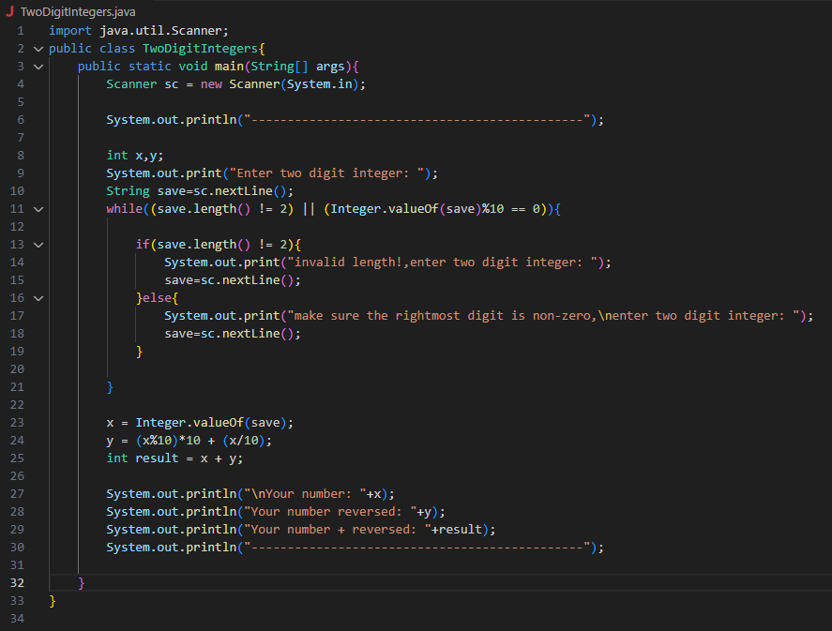

**Output:**

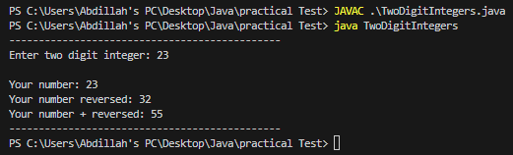

1. Write a program that plays a word game with the user. The program should ask the user to enter the following:

His or her name, His or her age, The name of a city, The name of a college, A profession, A type of animal, A pet’s name After the user has entered these items, the program should display the following story, inserting the user’s input into the appropriate locations There once was a person named **NAME** who lived in **CITY**. At the age of **AGE**, **NAME** went to college at **COLLEGE**. **NAME** graduated and went to work as a PROFESSION. Then, **NAME** adopted a(n) ANIMAL named **PETNAME**. They both lived happily ever after!

**Program:**

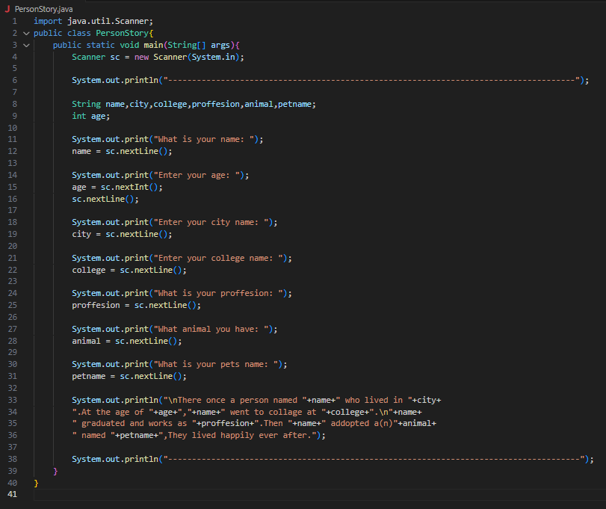

**Output:**

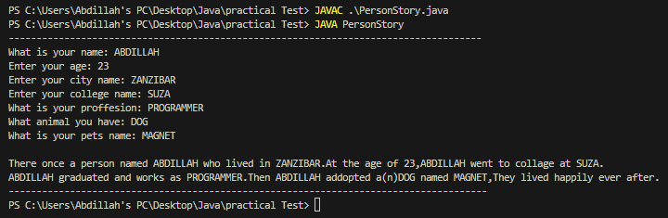

1. A particular employee earns $32,500 annually. Write a program that determines and displays what the amount of his gross pay will be for each pay period if he is paid twice a month (24 pay checks per year) and if he is paid bi-weekly (26 check per year).

**Program:**

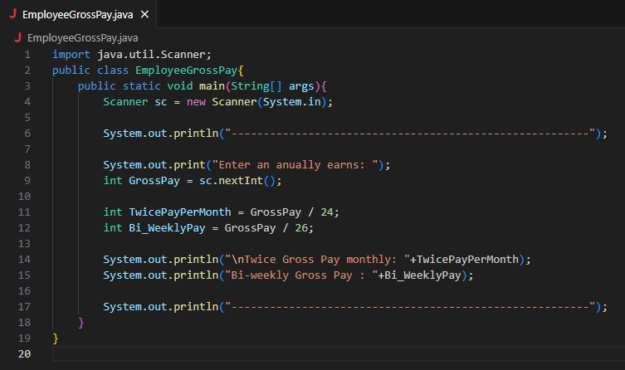

**Output:**

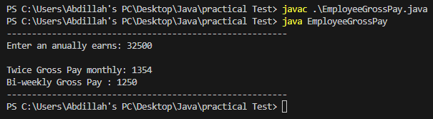

1. A county collects property taxes on the assessed value of property, which is 60 percent of its actual value. For example, if a house is valued at $158,000.00 its assessed value is $94,800. This is the amount the homeowner pays tax on. If the tax rate is $2.64 for each $100.00 of assessed value, the annual property tax for this house would be $2502.72. Write a program that asks the user for the actual value of a piece of property and the current tax rate for each $100.00 of assessed value. The program should then calculate and display how much annual property tax the homeowner will be charged for his property.

**Program:**

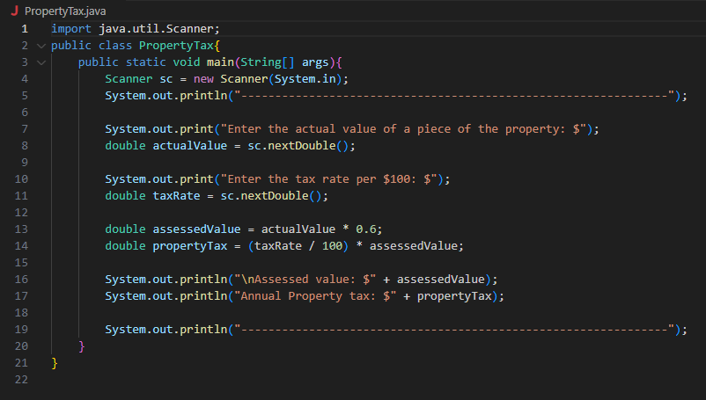

**Output:**

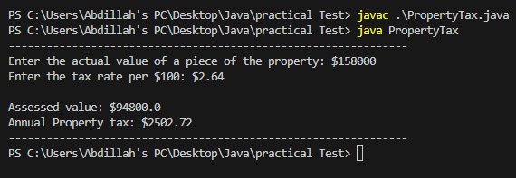

1. A person is eligible to be a US senator if they are at least 30 years old and have been a US citizen for at least 9 years. To be a US representative these numbers are 25 and 7, respectively. Write a program that accepts a person's age and years of citizenship as input and outputs their eligibility for the Senate and House.

**Program:**

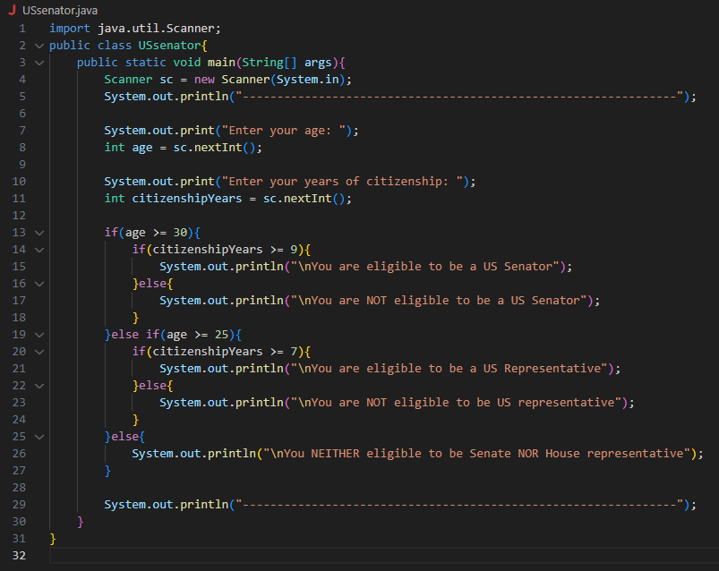

**Output:**

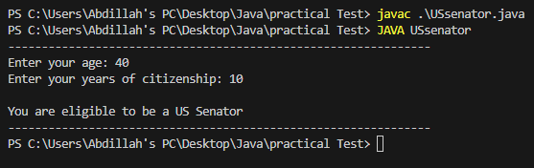

1. A palindrome is a number or a text phrase that reads the same backwards as forwards. For example, each of the following five-digit integers is a palindrome: 12321, 55555, 45554 and 11611. Write a program that reads in a five-digit integer and determines whether it is a palindrome.

**Program:**

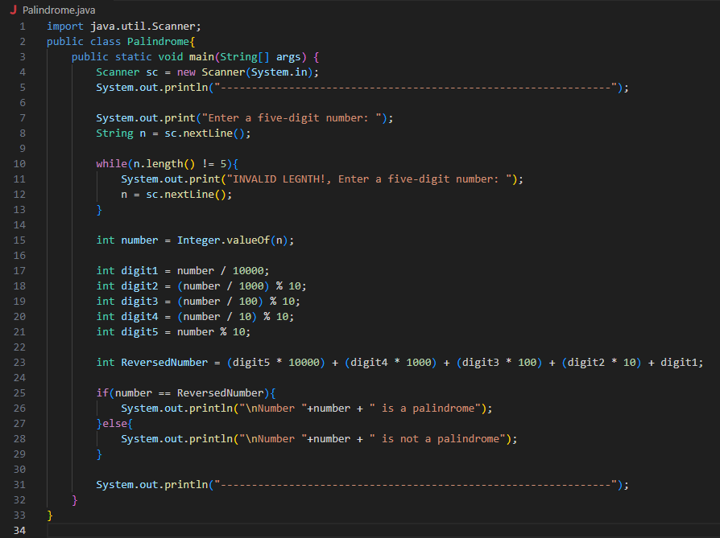

**Output:**

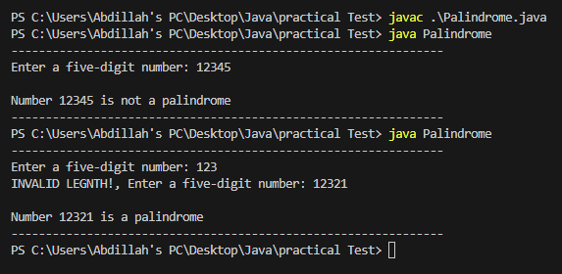

1. The owners of the Kwality Supermarket would like to have a program that computes the weekly gross pay of their employees. The user will enter an employee’s ID number, the hourly rate of pay, and the number of hours worked for the week. In addition, Kwality Supermarkets would like the program to compute the employee’s net pay and overtime pay. Overtime hours, any hours over 40, are paid at 1.5 the regular hourly rate. Net pay is Gross minus deductions. Assume that deductions are made up of income tax (at 15% of gross if the gross exceeds 500.00) and a 20 parking charge.

**Program:**

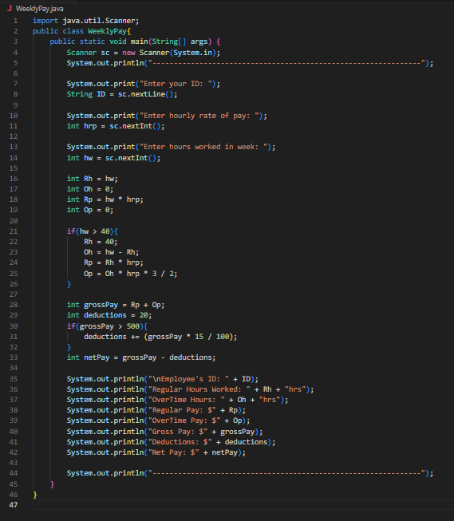

**Output:**

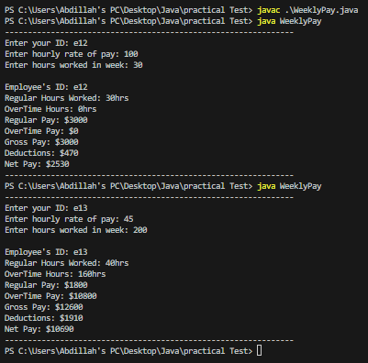

1. Write a program that asks for the names of three runners and the time, in minutes, it took each of them to finish a race. The program should display the names of the runners in the order that they finished.

**Program:**

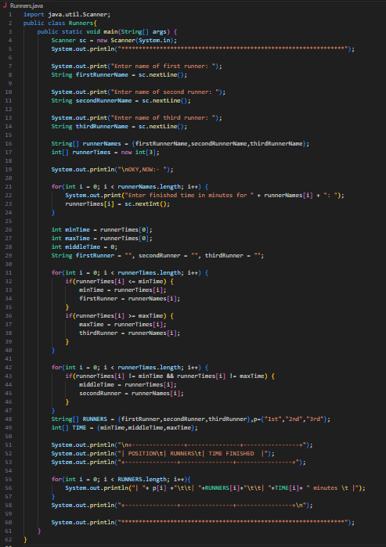

**Output:**

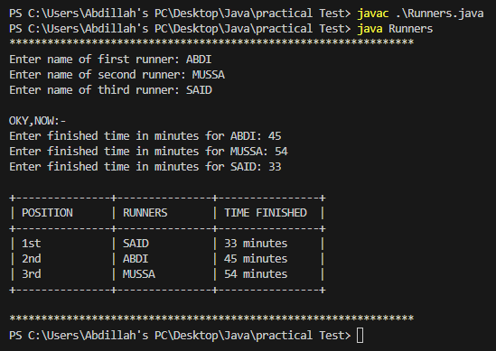

1. A certain CS professor gives 5-point quizzes that are graded on the scale 5-A, 4-B, 3-C, 2-D, 1-F, 0-F. Write a program that accepts a quiz score as an input and uses a decision structure to calculate the corresponding grade.

**Program:**

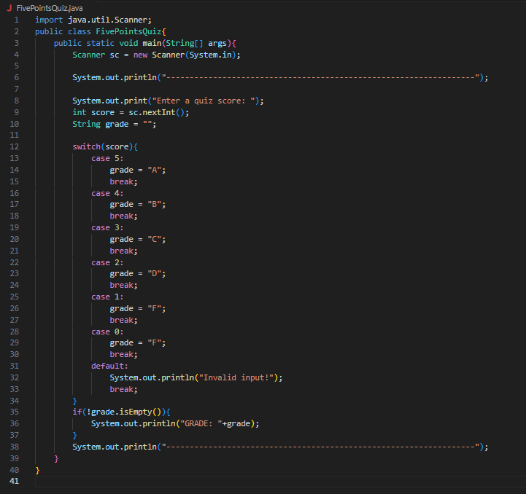

**Output:**

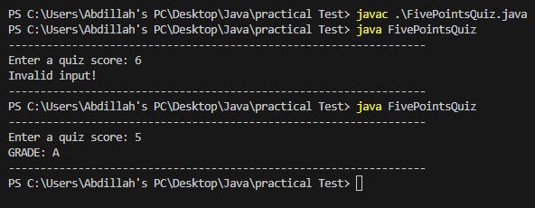

1. Write a Java program that uses a while statement and the tab escape sequence \t to print the following table of values:

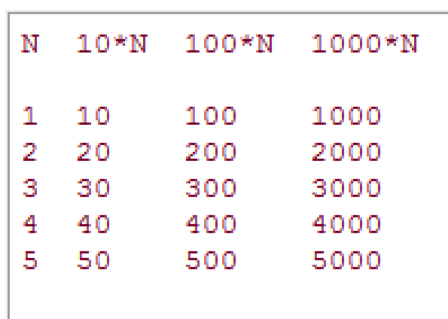

**Program:**

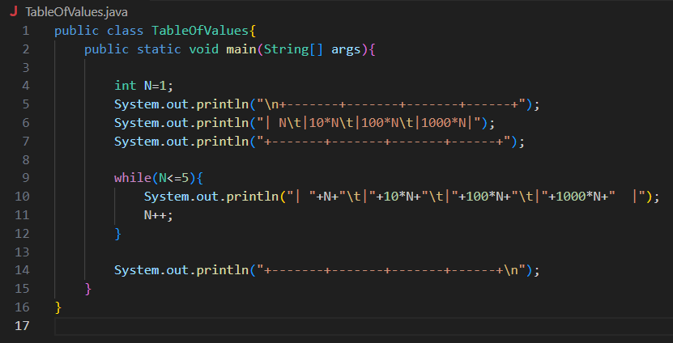

**Output:**

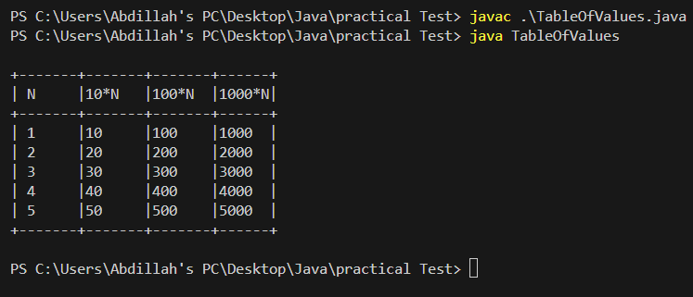

1. The distance a vehicle travels can be calculated as follows :

*distance* = *speed* * *time*

For example, if a train travels 40 miles per hour for three hours, the distance traveled is 120 miles. Write a program that asks the user for the speed of a vehicle (in miles per hour) and the number of hours it has traveled. It should then use a loop to display the distance the vehicle has traveled for each hour of that time period. Here is an example of the desired output:

What is the speed of the vehicle in mph? **40**e

How many hours has it traveled? **3**e

Hour Distance Traveled

1. 40
2. 80
3. 120

**Program:**

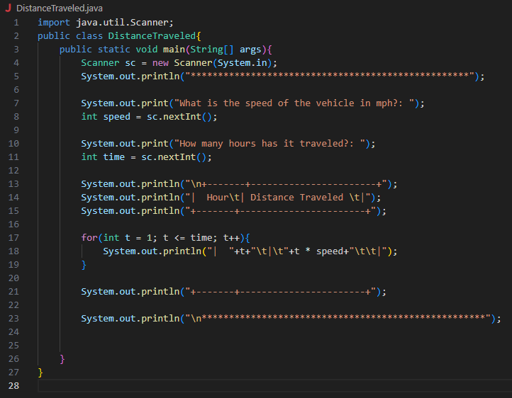

**Output:**

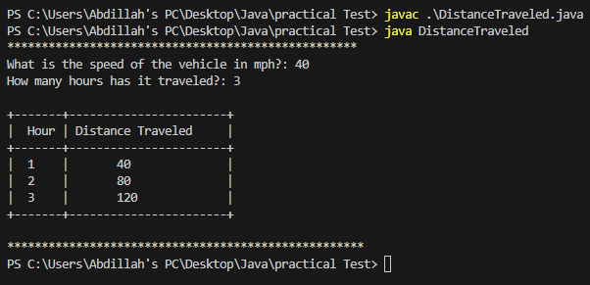

1. Write a program that uses nested loops to collect data and calculate the average rainfall over a period of years. The program should first ask for the number of years. The outer loop will iterate once for each year. The inner loop will iterate twelve times, once for each month. Each iteration of the inner loop will ask the user for the inches of rainfall for that month. After all iterations, the program should display the number of months, the total inches of rainfall, and the average rainfall per month for the entire period.

**Program:**

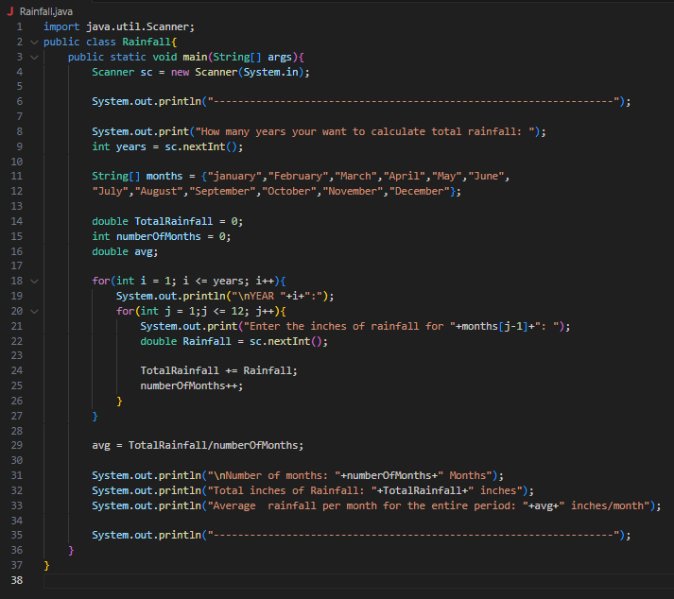

**Output:**

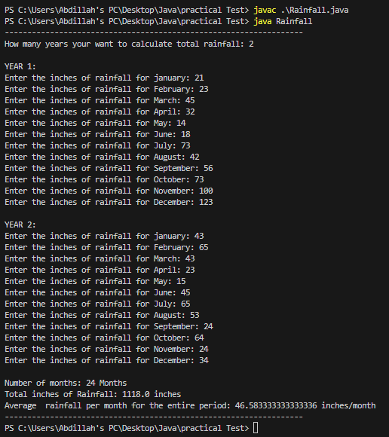

1. Write a program with a loop that asks the user to enter a series of positive numbers. The user should enter a negative number to signal the end of the series. After all the positive numbers have been entered, the program should display their sum.

**Program:**

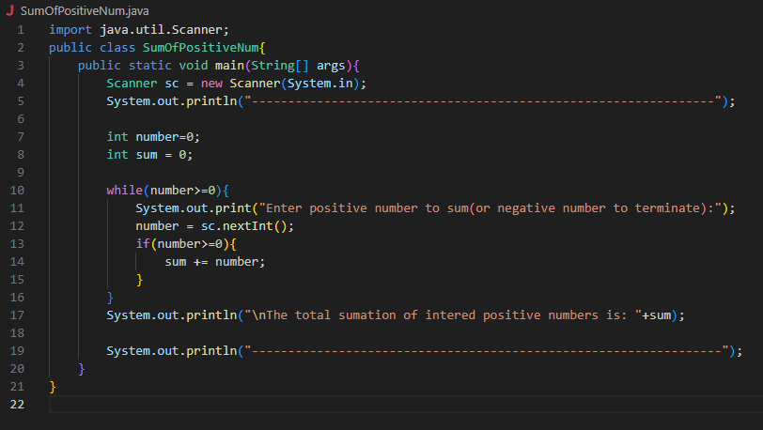

**Output:**

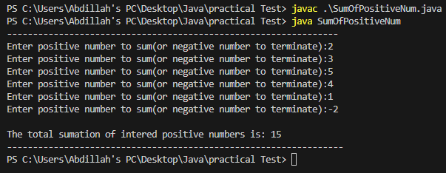

1. Write a program that gets a value from the user and then prints mathematical table as show below.

For example user input 7, it should print like this below

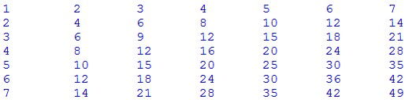

**Program:**

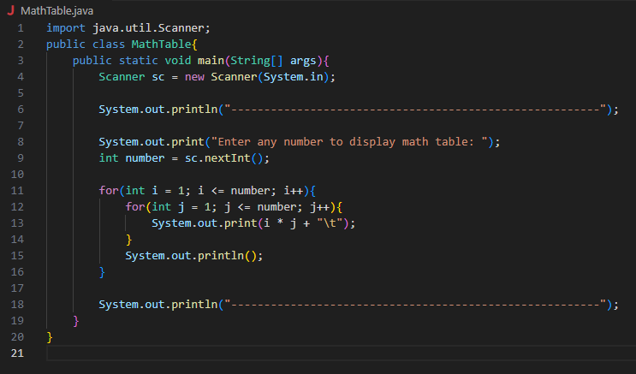

**Output:**

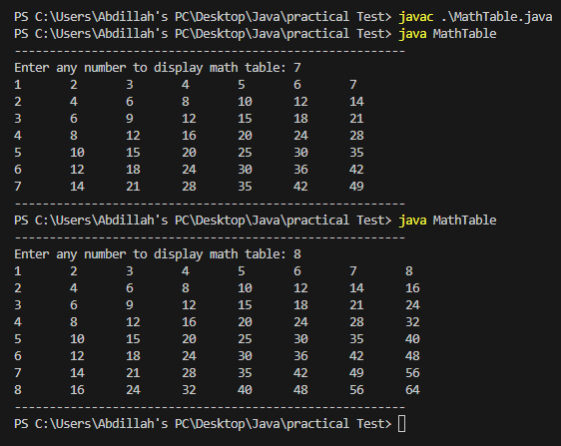

1. Write a program with a loop that lets the user enter a series of integers, followed by -99 to signal the end of the series. After all the numbers have been entered, the program should display the largest and smallest numbers entered. Do NOT use any build-in functions.

**Program:**

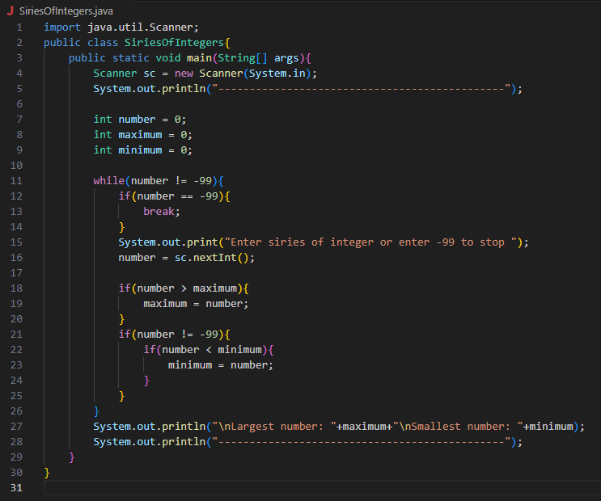

**Output:**

